lab 3 - Proof of Concept (POC)
Generated from the provided screenshots and notes.

Step 1
check the multipe request like home , cart ,checkout and send to repeter
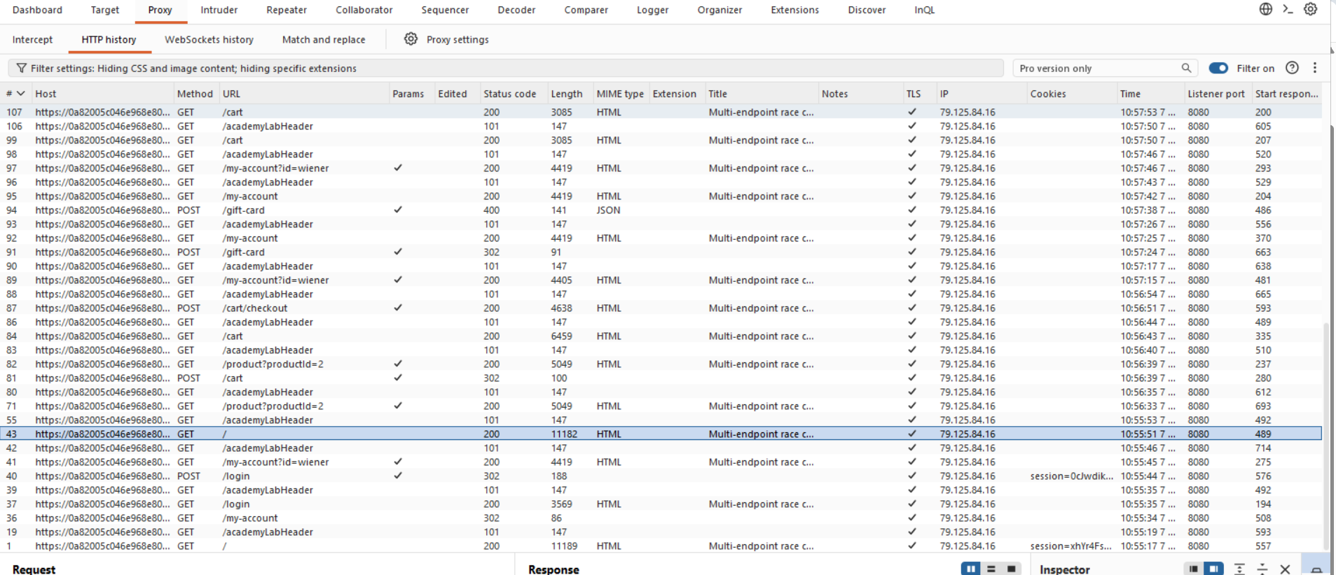

Step 2
create a grp in car and checkout and change the product id into 1 from the cart request
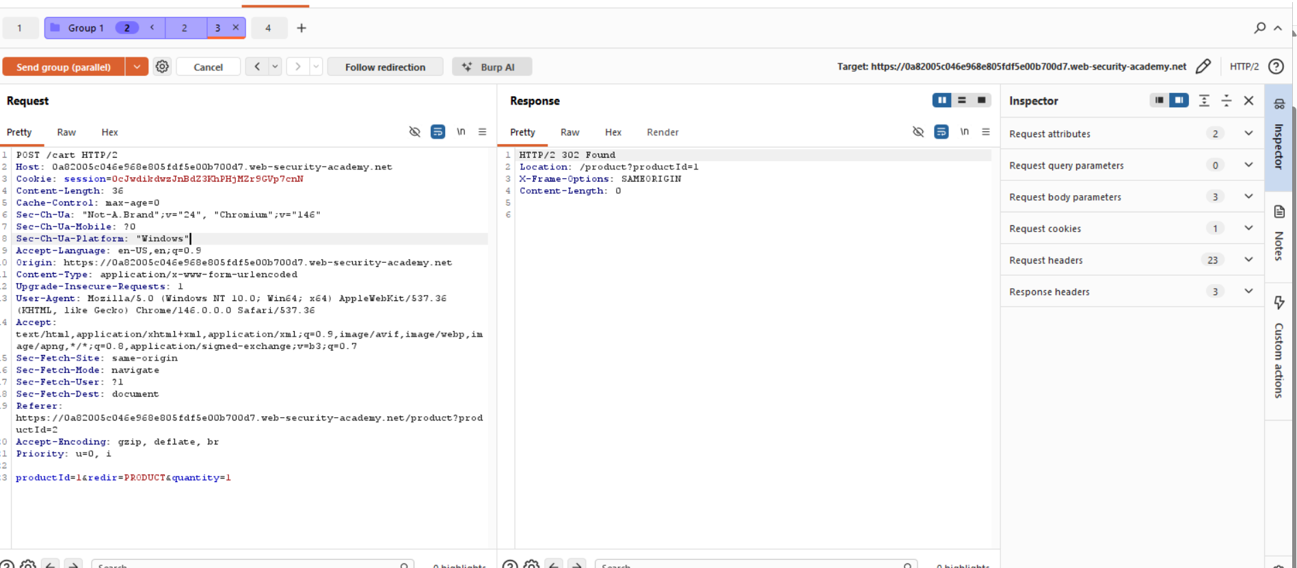

Step 3
send the request home with ctl+space and same send the request on the grp cart request ctl+space
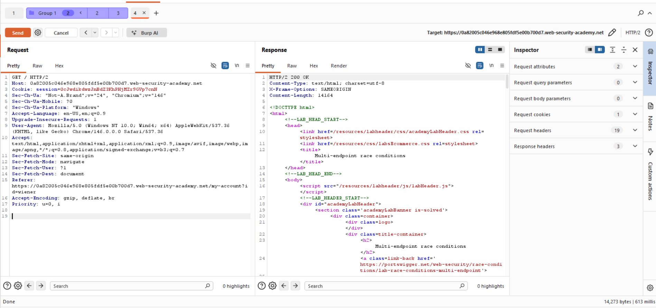

Lab Solved
lab solved
